[](https://www.google.com/url?sa=i&url=https%3A%2F%2Flavocatdelaterreur.com%2Fcodification-of-international-law%2F&psig=AOvVaw2oqk5CAvRPZiEwqwGJGmN-&ust=1585341530867000&source=images&cd=vfe&ved=0CAIQjRxqFwoTCLitrcj_uOgCFQAAAAAdAAAAABAE)

Year 11 Pre- study Workpack

A-level Law

[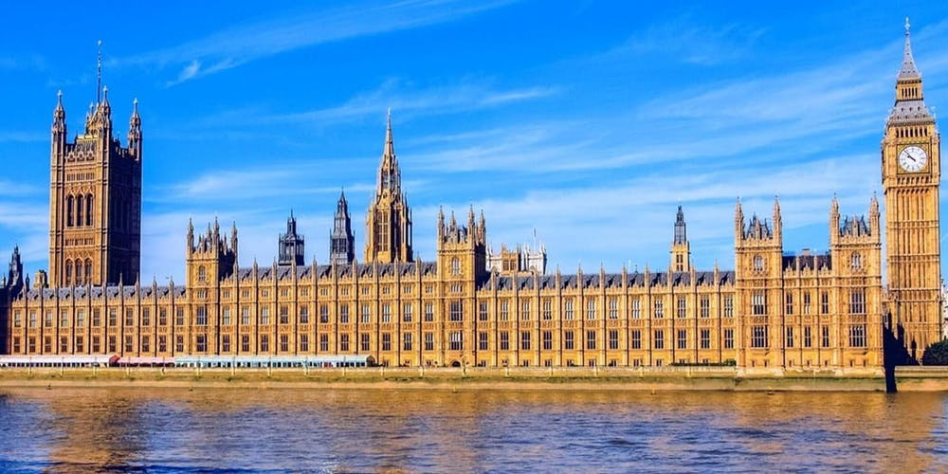](https://www.google.com/url?sa=i&url=https%3A%2F%2Fparkside.herts.sch.uk%2Fschool-council-visit-the-houses-of-parliament%2F&psig=AOvVaw0Xvh0dBI_OycgYr3_enNJS&ust=1585341699961000&source=images&cd=vfe&ved=0CAIQjRxqFwoTCPCK9JiAuegCFQAAAAAdAAAAABAP)

[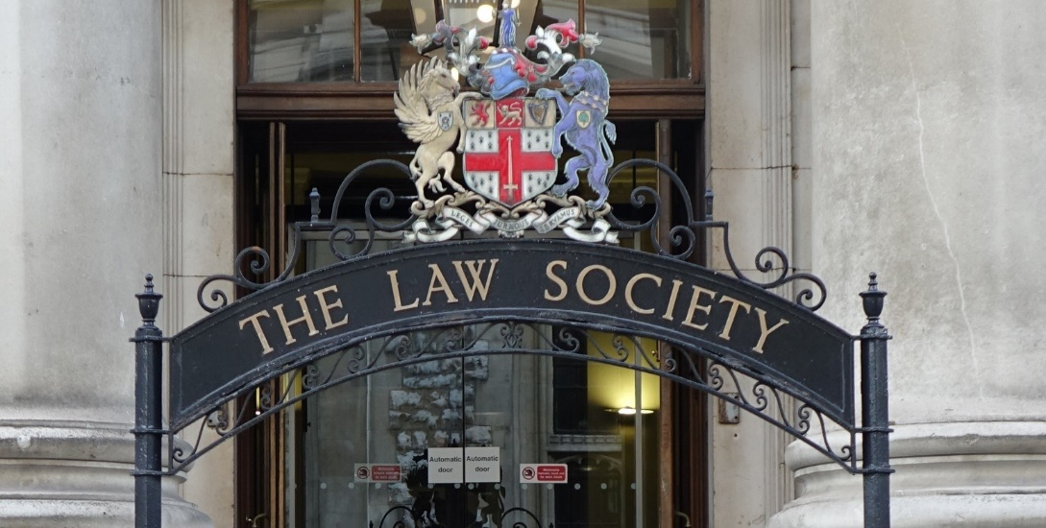](https://www.google.com/url?sa=i&url=https%3A%2F%2Fwww.linkedin.com%2Fcompany%2Fthe-law-society-of-england-and-wales&psig=AOvVaw2oqk5CAvRPZiEwqwGJGmN-&ust=1585341530867000&source=images&cd=vfe&ved=0CAIQjRxqFwoTCLitrcj_uOgCFQAAAAAdAAAAABAK)[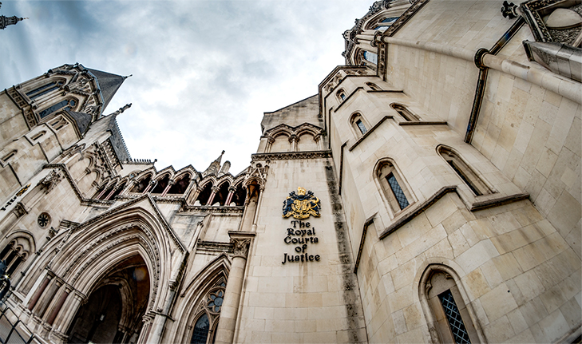](https://www.google.com/url?sa=i&url=https%3A%2F%2Ftheroyalcourtsofjustice.com%2F&psig=AOvVaw3ovpHlkvIiRCxgOq7kmX-0&ust=1585341877032000&source=images&cd=vfe&ved=0CAIQjRxqFwoTCIi9su2AuegCFQAAAAAdAAAAABAK)

**Introduction**

We are very glad that you are interested in studying law. This work pack is designed to give you an insight into the topics you will study as part of the Alevel course and to provide you with some suggested activities that will help you prepare for starting the course in September.

At Runshaw we study under the OCR specification which covers six main topic areas which are examined across three 2 hour exams at the end of the second year. These topics are:

**English Legal Systems**: This covers things such as the role of juries, solicitors and barristers as well as trial procedure and sentencing.

**Law Making**: This looks at the different sources of law from Parliament to Local Authorities and Judge Made Law known as precedent.

**Criminal Law**: In this topic we look at a selection of different criminal offences such as murder, assault and theft as well as the defences available.

**Tort Law:** This covers civil liability for issues that arise under negligence, nuisance and vicarious liability (employers being liable for their employee’s actions).

**Contract Law:** A very practical topic looking at how contracts are formed and broken as well as the protections available for consumers.

**Nature of Law:** This topic ties the whole course together looking at the philosophy behind the law and its relationship with morality, justice, society and technology.

**The course textbooks are:**

**OCR LAW 1 and OCR LAW 2, both Jacqueline Martin and Nicholas Price, Hodder Education.**

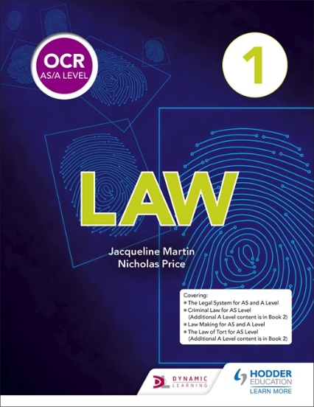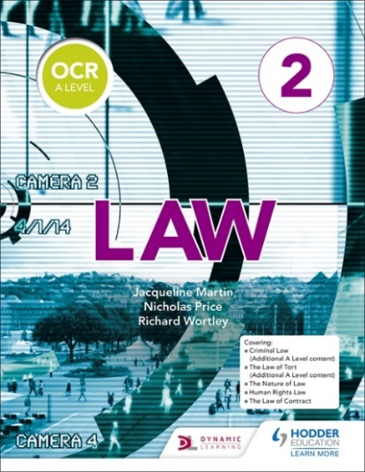

Additional Reading

As Law is an ever changing subject it is a very good idea to keep upto date with current events by watching the news and reading newspapers.

You can also make use of social media such as Twitter simply search for and ‘follow’ @RunshawLaw. Following news outlets is also a good idea.

You can also access the RunshawLaw Youtube channel where there are lots of revision videos and clips here that you may find useful and interesting.

You can also do some wider reading around elements of the law you find particularly interesting. Below is a list of books that you may find interesting if you are looking for some wider law related reading:

*Letters to a Law Student*

Nicholas McBride, Longman 2006.

ISBN 9780582894259

[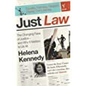](http://www.amazon.co.uk/Just-Law-Helena-Kennedy/dp/0099458330/ref=sr_1_2?ie=UTF8&s=books&qid=1277476171&sr=1-2)*The Path to Pupillage* *– A Guide for the Aspiring Barrister*

Sweet & Maxwell, 2008

ISBN 9781847034014

[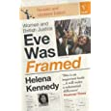](http://www.amazon.co.uk/Eve-Was-Framed-British-Justice/dp/0099224410/ref=sr_1_1?ie=UTF8&s=books&qid=1277476171&sr=1-1)*Learning the Law*

Glanville Williams & ATH Smith, 13 Ed. Sweet & Maxwell, 2006

ISBN 9780421925502

*Eve was Framed: Women and British Justice*

Helena Kennedy QC, Vintage, 1993

ISBN 9780099224419

[](http://www.amazon.co.uk/Memoirs-Radical-Lawyer-Michael-Mansfield/dp/0747576548/ref=pd_sim_b_10)

*Memoirs of a Radical Lawyer*

Michael Mansfield

2009

ISBN 0747576548

[](https://www.google.com/url?sa=i&url=https%3A%2F%2Fwww.upwork.com%2Fblog%2F2009%2F05%2Ftop-25-project-management-blogs%2F&psig=AOvVaw3jaXxe75f97iJpy16oFSvA&ust=1585344344886000&source=images&cd=vfe&ved=0CAIQjRxqFwoTCOiCnIaKuegCFQAAAAAdAAAAABAE)**Activity**

[](https://www.google.com/url?sa=i&url=https%3A%2F%2Fwww.upwork.com%2Fblog%2F2009%2F05%2Ftop-25-project-management-blogs%2F&psig=AOvVaw3jaXxe75f97iJpy16oFSvA&ust=1585344344886000&source=images&cd=vfe&ved=0CAIQjRxqFwoTCOiCnIaKuegCFQAAAAAdAAAAABAE)To help you start to develop an insight into how the law affects us all on a daily basis and to get you thinking about key elements of the course we would like you to complete a project/scrapbook relating to the current Covid-19 pandemic. Below is the information you need to include but feel free to add extra details/information.

1. Find a new law that has been created in response to the Covid-19 crisis, you can find details of new laws at <http://www.legislation.gov.uk/new/data.feed> as well as those you hear bout in the news. Provide the following information:
   1. What is it called?
   2. Is it Primary (Created by Parliament known as an Act) or Secondary (created by someone else i.e. Local Authority) Legislation?
   3. If secondary who created it?
   4. What is the law designed to do? Why was it introduced?
   5. Find an example of the law being enforced or make up a scenario where the law would be used.
   6. Do you think this is a good law?
      1. Think about whether it is written well?; will they be able to enforce it easily?; is it morally right?; does it infringe on your human rights?; is this justified? etc.
2. Is there a law that you think should have been introduced to deal with this crisis?

[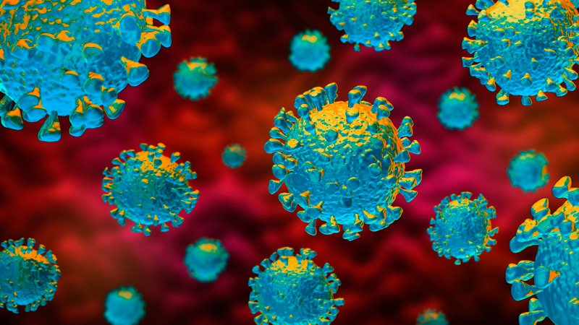](https://www.google.com/url?sa=i&url=https%3A%2F%2Fwww.medscape.com%2Fviewarticle%2F925588&psig=AOvVaw0XVUrWLmMtVrkno1H_1ozY&ust=1585344431440000&source=images&cd=vfe&ved=0CAIQjRxqFwoTCIjata-KuegCFQAAAAAdAAAAABAE)

We look forward to seeing you and your projects in September!