Firstly, importantly, we hope you are keeping safe and well. The intention here is to support you in making progress with your photography studies, but we also appreciate circumstances will vary greatly. Some of you will have easy access to cameras, printers or outdoor spaces; others may be less fortunate or have more immediate priorities.
So with all this in mind, an important point: what follows is written with a genuine belief that photography and art making can be a remarkable force for good - be it as a welcome distraction, a means of reflection or understanding, an opportunity to record this unprecedented moment in history...
Despite the challenges, you’re learning remains in your hands, and that's a good thing for creative development. It starts with a deliberate decision on your part - to pick up your camera or phone (or pen or pencil, even) and take control: to choose a theme and move to action. Below are a few tips to help:
- Set out to be disciplined, persistent and, importantly, interested. Plan and protect your time for creative work each day - something to look forward to.
- If necessary, explain to your family that your photography studies are important and you might need space, time and understanding, perhaps even a willing model.
- Set short-term targets whilst also remaining open to unexpected possibilities and 'happy accidents’. Pay attention to the subtle details, the unexpected outcomes and mistakes, the difficulties and challenges.
- Keep track of experiments and related research and thoughts through regular notes, images, blog posts or perhaps a video diary.
​
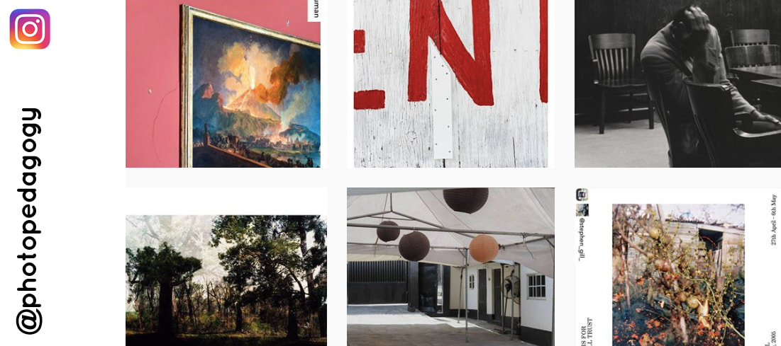
Our @photopedagogy instagram feed regularly shares ideas, resources and links that might prove useful during this period of lockdown. One of the fascinating positives to emerge from this pandemic is an outpouring of creative sharing and collaboration. Hashtags such as #massisolationproject and #lifeatsixfeet are great examples of how photography is documenting personal experiences and connecting those in isolation.

So, where to begin?
If you have a current project or task that you are struggling with it is important, if possible, to share your thoughts with your teacher. Remember it's a challenging time for teachers too and it is not always easy to monitor student understanding and engagement at a distance. It's much better to take control of your own photography learning than do nothing. This is what the most successful students have always done - pursue their own ideas and experiment independently. With this in mind, the following resources are being regularly developed under 2 sections - the priorities that we believe help students the most:
​
- Practical action - taking/making images (which might also include drawing, film, animation, installation, sculpture...) and exploring ideas, materials and techniques. It's also important to document this as you go, being reflective and thinking critically.
- Reflective reading (and writing practice) - Researching the work of other artists/photographers (and wider contexts, such as related themes, histories and connections...) AND practicing your own writing skills.
We hope that these suggestions will capture your interest and help you to navigate and document your own experiences in a way that is purposeful, enriching and enjoyable. Try to experiment in a way that is progressive - that demonstrates a sense of moving forward, being reflective and making sensitive connections between each step.
​
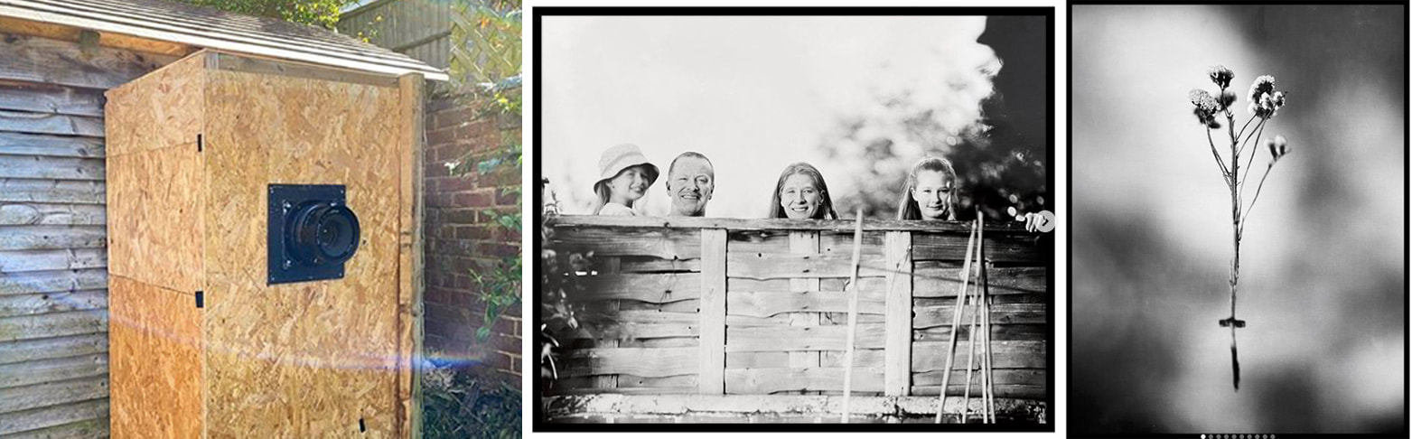
Brendan Barry is a photographer, educator and camera builder whose creative photographic practice combines elements of construction, education, performance and participation. His instagram feed during lockdown @brendanbarryphoto is a wonderful insight into his passion and ingenuity for photography and its processes. The images above show his garden shed.

