**Tips for improving your skills in Photoshop & Illustrator**

On A-Level Graphics you will learn how to use digital software including Photoshop & Illustrator. We teach you how to use this software, but if you would like to try this, install a free trial version of both programmes and have a go!

**ADOBE PHOTOSHOP**

Imaging and graphic design software used for photo editing and compositing to digital painting and animation.

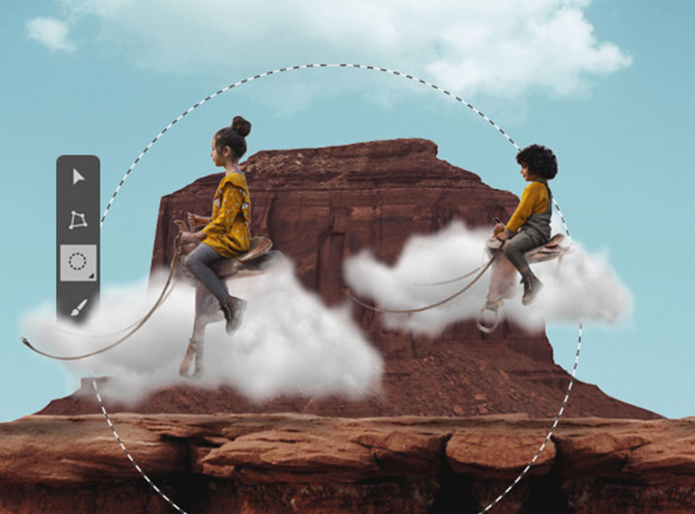

Download a FREE TRIAL of PHOTOSHOP at -https://www.adobe.com/uk/creativecloud/buy/students.html?promoid=65FN7X8B&mv=other

**Tutorials**

***GET TO KNOW PHOTOSHOP:***

https://helpx.adobe.com/uk/photoshop/how-to/ps-basics-fundamentals.html?playlist=/services/playlist.helpx/products:SG_PHOTOSHOP_1_1/learn-path:get-started/set-header:ccx-designer/playlist:ccl-get-started-1/en_GB.json&ref=helpx.adobe.com

***FOR MORE PHOTOSHOP TUTORIALS VISIT:***

https://helpx.adobe.com/uk/photoshop/tutorials.html

**ADOBE ILLUSTRATOR**

Industry standard vector graphics software to create everything from web and mobile graphics to logos, icons, book illustrations, packaging and adverts.

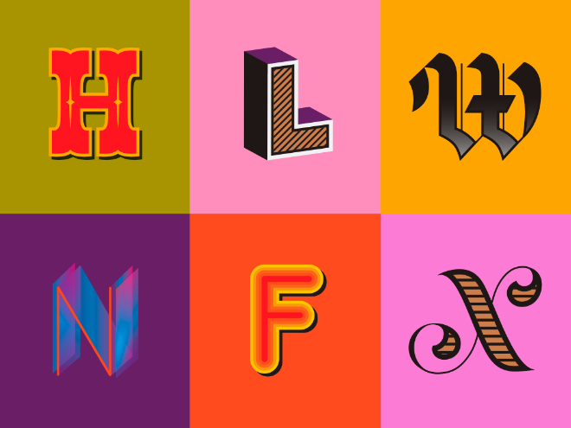

Download a FREE TRIAL of ILLUSTRATOR at -https://www.adobe.com/uk/creativecloud/buy/students.html?promoid=65FN7X8B&mv=other

**Tutorials**

***GET TO KNOW ILLUSTRATOR:***

https://helpx.adobe.com/uk/illustrator/how-to/ai-basics-fundamentals.html?playlist=/services/playlist.helpx/products:SG_ILLUSTRATOR_1_1/learn-path:get-started/set-header:ccx-designer/playlist:ccl-get-started-1/en_GB.json&ref=helpx.adobe.com

***FOR MORE ILLUSTRATOR TUTORIALS VISIT:***

https://helpx.adobe.com/uk/illustrator/tutorials.html