CV Revision Booklet
Use your own workbooks to answer the questions

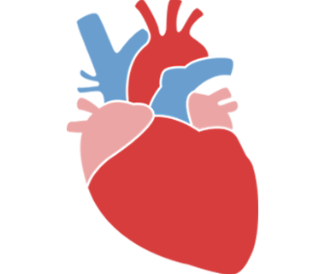
- What are the other functions of the heart?
  - Deliver O2 and nutrients
  - Remove waste products

- Label the Heart

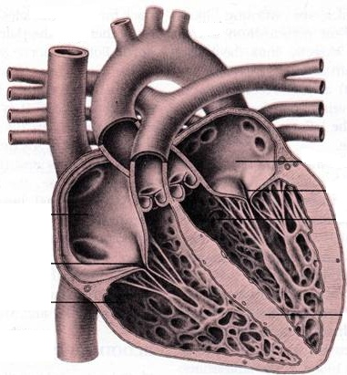

- What do the bicuspid and tricuspid valves do?

- Describe the epicardium, myocardium and endocardium

- What is the function of the coronary artery?

- Describe the difference of arteries/arterioles and veins/venules

- What do capillaries do?

- Complete the table
Component | Description / function
Plasma
Red blood cells
White blood cells
Platelets
- What is the function of the lymphatic system
10..How does vasodilation and vasoconstriction work in exercise?
11..How does blood pressure alter during exercise?
12. Describe neural control of the heart

13. How is the heart rate controlled?

